**Product should be hero and other lessons in innovation from ID Fresh Food’s PC Musthafa**

[yourstory.com](https://yourstory.com/2020/11/id-fresh-food-pc-musthafa-innovation-lessons-brand-building-techsparks-2020?utm_source=Email&utm_medium=YourStoryBuzz&__sta=vhg.hhksexQJekqoc%7CBBYV&__stm_medium=email&__stm_source=smartech)

Dipti Nair

8-10 minutes

From never giving up, to now learning how to give up, PC Musthafa’s story is a series of learnings and unlearning. And then learning some more.

The Co-founder and CEO of ID Fresh Foods, popular for its idli-dosa batter nationwide, has had a spectacular journey from having to skip his daily breakfasts as a child because his family could not afford it, to now enabling millions of households to make fresh idlis for breakfast.

Musthafa is now on a quest to make ID Fresh Foods a unicorn in the fresh food business. According to publicly available information, ID Fresh Food (India)'s operating revenues range between Rs 100 crore and Rs 500 crore for FY2019, and it's EBITDA has increased by 84.12 percent over the previous year.

“I have learnt to hustle and make money the right way since childhood,” Musthafa says in a **fireside chat at TechSparks 2020** that concluded last week.

**“One thing that guided me and stays with me even today is the power of determination. These three words, ‘power of determination’ have got us where we (his company) are today,” he says.**

Son of a porter from Kerala’s Wayanad region, Musthafa started the business in 2005 with his four cousins — Abdul Nasser, Shamsudeen TK, Jaffer TK, and Naushad TA -- from a small kitchen with just Rs 50,000.

“With that money, we bought one grinder, one mixer, one sealing machine, one weighing scale, and a second-hand Scooty,” he says. Their daily routine included going to the market to buy rice and daal, soak it overnight, grind it, and package it.

**“The next day, we would load the batter and go to the market. It was back-breaking work. Our shirts would be soaked with sweat,” he recalls the hard days.**

It took them nine months to get 20 customers and sell 100 packets of batter a day. Today, ID Fresh Food products are available across more than 35 cities in India and the Middle East.

“If you look at our background, we had no experience in making breakfast or in food technology. Forget about making breakfast, we did not even know what breakfast was,” he says, adding,

“My cousins and I tried our best not to give up. We gave ourselves six months to sell 100 packets daily. But that did not happen. We ended up selling only 50 packets of batter daily.”

At that point, Mustafa was working with an IT company and could support the business. “I think that helped. If I had quit my well-paying job then I wouldn’t have had the determination to stay invested,” he adds.

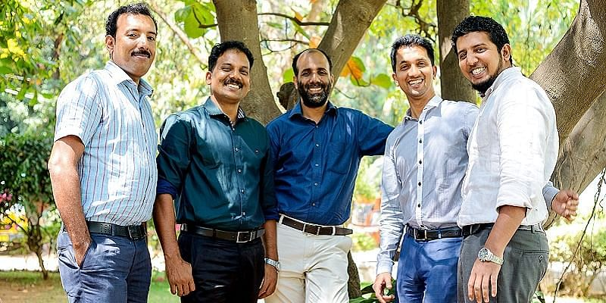

*Musthafa (second from right) with his co-founders.*

The next level of challenge for Musthafa and his co-founders is to take his company to a unicorn status worth a billion dollars. The company has so far raised two rounds -- one from Helion Ventures in 2014 and another from Premji Invest in 2017 when it raised $25 million. The company is today valued at $200 million plus.

`

**While Musthafa was determined not to give up in the initial stages, at this stage, he is determined to give up!**

Indicating that at this point in his business journey when he is scaling the business, he has to learn to delegate and focus on the bigger vision of the company.

“I am learning to give up many things I was doing earlier, like day to day operations. I had to learn new skills in delegating. I am trying to develop this skill,” he says.

**The second thing that he is learning at this stage of his career is focusing on the bigger picture from a strategic perspective. And the third is focus on brand building and team building.**

**How to innovate and build your brand**

“These days you see companies spending a lot of money on brand building. But how many of those brands do we actually remember beyond a point,” he observes.

He feels the best way to build a brand is not to spend money blindly on marketing.

* First, look at it as a triangle: the first part should be your product. The product has to be the hero. If you don’t get your product right, don’t even think of building a brand. Don’t waste money.
* Second, give a memorable user experience.
* Third and most important (but ignored by most) is well-crafted storytelling. People do not remember ads, they remember stories. That is where we did our job well.

**Innovation plays an important role in any business. Musthafa shares his four principles of innovation.**

* The first is **product innovation**. Example: ID coffee decoction. When everyone was selling coffee powder, we decided to sell liquid decoction. We focused on the core of **keeping the product preservative-free and 100 percent natural**. That was our differentiation.
* The second is **business model innovation**. When the whole world was doing R&D for product shelf life extension, we kept the products fresh. **And we built a zero inventory model business across. Whatever we manufacture today will be ready for dispatch tomorrow.** We replenish stocks daily.
* The third is the **packaging innovation**. Vada maker is a classic example of using packaging to deliver a unique experience. Usually, the packaging is meant for transporting the product from one place to another. It is also used to preserve the freshness of the product, to communicate the right message to the consumer. For example, ID Paneer. The message on the package says, ‘This paneer is made from lemons. Beware, there could be lemon seeds inside’. This indicates the product is without any preservatives. **Another function of the packaging is to deliver functionality and unique experience.** So for the vada packaging, when you squeeze the packet you get the hole in the middle vadas just like how the eateries and restaurants make them. **Packaging innovation is something we invested in the last couple of years.**
* The fourth is **marketing innovation**. We didn’t have money to invest in large campaigns. **In the last 15 years, we have invested less than Rs 20 crores in marketing.** We used the right themes to get us market leverage. Example: our trust shops. We did not do it just for the sake of a campaign. We had a business problem to solve. **We were trying to sell the world’s best food, idli, in a packaged form. It is like an oxymoron. People are skeptical about packaged food being hundred percent preservative free. My biggest problem was how to make my customers trust my product.** Such was the success with some of these trust shops that they were giving me better revenue than retail stores.

“In this experiment (of running trust shops) what I have learned is Indians are trustworthy. If you trust them, they will trust you back. It has to be a hundred percent trust. Takes time to earn that trust. But once you earn the trust, it stays,” says Musthafa.

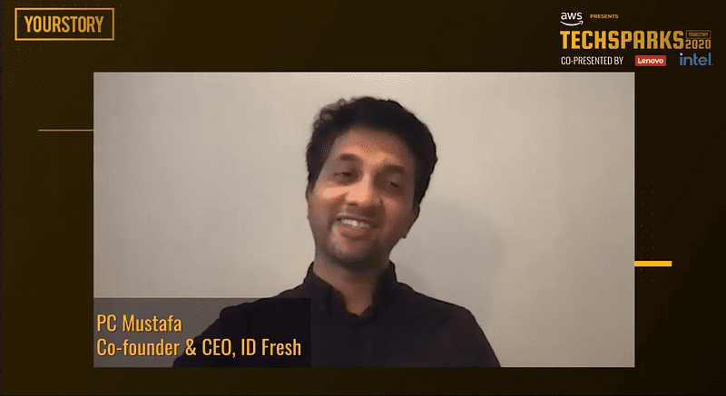

**What he knows now that he did not know then**

* In the last few months, **I have learnt to do more with less**. We have done better revenue, better profitability in the last few months compared to pre-COVID-19 times.
* Another thing I have learnt is the **importance of trust. It’s a magical weapon.** Once you own a customer’s trust, nothing can stop you after that.
* The third is the importance of innovation. You can innovate in any business, provided you have common sense. **We unnecessarily complicate things. We believe innovation is born in excel sheets.**
* To innovate, identify customer problems and solve it using simple science and common sense. That is the best way to build a brand and stay ahead of the competition. Always upgrade yourself so that competitors cannot catch up.

TechSparks - YourStory's annual flagship event - has been India's largest and most important technology, innovation, and entrepreneurship summit for over a decade, bringing together entrepreneurs, policymakers, technologists, investors, mentors, and business leaders for stories, conversations, collaborations, and connections that matter. As TechSparks 2020 goes all virtual and global in its 11th edition, we want to thank you for the tremendous support we've received from all of you throughout our journey and give a huge shoutout to our sponsors of TechSparks 2020.